1. A particle initially traveling at 40 m/s slows to 10 m/s in just 3 seconds at a constant acceleration. How far does the particle travel?

(A) 25 m

(B) 30 m

(C) 75 m

(D) 90 m

(E) 120 m

2. A projectile is launched from a 25 m platform at an angle of 30° to the horizontal. Its initial velocity is 40 m/s. How long is it in the air?

(A) 2 s

(B) 3 s

(C) 4 s

(D) 5 s

(E) 6 s

3. A boy uses a string to swing a 1.5 kg stone around his head. If the string is 1.5 m, and can bear a maximum tension of 1600 N, what is the maximum speed at which the boy can swing the stone without breaking the string?

(A) 40 m/s

(B) 400m/s

(C) 800m/s

(D) 1600m/s

(E) 2000m/s

4. A man dangles a 10 kg mass from the end of a rope. If he jumps from a plane while still holding the rope, the tension in the rope will be:

(A) 0 N

(B) 5 N

(C) 10 N

(D) 20 N

(E) 30 N

5. A crate with a mass of 13.8 kg is pulled by a rope across a smooth level floor. Friction is negligible. When a force of 53.2 N is applied to the rope the crate accelerates at 2.8 m/s2. What angle does the rope make with the floor?

(A) 40º

(B) 30º

(C) 60º

(D) 21.6º

(E) 43.4º

6. The airspeed of a plane is 207 km/h and the pilot keeps the plane pointed north. A wind is blowing 64.3 km/h from the west. Determine the speed of the plane relative to the ground.

(A) 216.8 km/h

(B) 210.8 km/h

(C) 222.8 km/h

(D) 250 km/h

(E) 180 km/h

7. How far from the center of the Earth would a person with a weight of 481 N on Earth have to be to have a weight of 53.9 N?

(A) 1000 km

(B) 45000 km

(C) 17000 km

(D) 17333.3 km

(E) 19058.9 km

8. A swimmer is on the south shore of a river 1.66 km wide. He wishes to swim to a dock due north of his starting point. His maximum speed in still water is 4.19 km/h and the current in the river is flowing 1.46 km/h to the west. How many degrees relative to the current must he swim?

(A) 10°

(B) 80°

(C) 90°

(D) 100°

(E) 110°

9. How much work is done by a crane lifting a 200 kg crate from the ground to a floor 21 m above the ground?

(A) 40000 J

(B) 12000 J

(C) 12233 J

(D) 41160 J

(E) 0 J

10. A car moving at 35 m/s on dry pavement, skids to a stop over 175 m. What is the coefficient of friction between the car’s tires and the pavement?

(A) 0.25

(B) 0.35

(C) 0.45

(D) 0.5

(E) 0.6

11. A 0.171 kg ball is thrown at 27.3 m/s at an angle of 37.3º above the horizontal. What is the kinetic energy of the baseball at the highest point of the trajectory?

(A) 00.3 J

(B) 90.6 J

(C) 32.1 J

(D) 30.14 J

(E) 40.32 J

12. A boy throws a ball vertically upwards from ground level. If the ball reaches a maximum height of 40 m and the gravitational acceleration is 9.8 m/s2, with what speed did the boy throw the ball?

(A) 70 m/s

(B) 15 m/s

(C) 20 m/s

(D) 19 m/s

(E) 28 m/s

13. Which of the following would require the greatest average force?

(A) Stopping a 5 kg ball moving at 9 m/s in one second

(B) Stopping a 7 kg ball moving at 7 m/s in one second

(C) Stopping a 10 kg ball moving at 5 m/s in one second

(D) Stopping a 12 kg ball moving at 4 m/s in one second

(E) Stopping a 10 kg ball moving at 4 m/s in one second

14. What minimum force F is required to lift the mass?

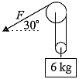

(A) 15 N

(B) 20 N

(C) 30 N

(D) 60 N

(E) 98 N

15. 201*Hg* undergoes electron capture to form:

(A) 200*Au*

(B) 201*Au*

(C) 201*Tl*

(D) 202*Tl*

(E) 200*Pb*

16. A diver swims in a pool that is 30 m deep. The diver swims 20 m above the bottom. What is the Absolute pressure?

(A) 1×104 Pa

(B) 1×105 Pa

(C) 2×105 Pa

(D) 4×105 Pa

(E) 5×105 Pa

17. At what velocity does fluid flow from Tank B to Tank A in the diagram below?

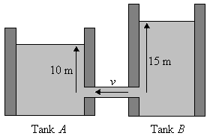

(A) 2.2 m/s

(B) 10 m/s

(C) 14 m/s

(D) 17 m/s

(E) 22 m/s

18. A 2.5 kg mass is projected straight upward with an initial kinetic energy of 980 J. If air resistance is ignored, how much kinetic energy will this projectile have as it strikes the ground?

(A) 20 J

(B) 200 J

(C) 200 kJ

(D) 980 kJ

(E) 980 J

19. Water moves past a water wheel, causing it to turn. The force of the water is 200 N, and the radius of the wheel is 10 m. Calculate the torque around the center of the wheel.

(A) 20 N∙m

(B) 200 N∙m

(C) 2000 N∙m

(D) 20000 N∙m

(E) 24000 N∙m

20. A 1 m glass tube is stood on end and partially filled with water. The air in the tube resonates when either a 440 Hz or a 1320 Hz tuning fork is vibrated at its opening. It does not resonate with a 147 Hz tuning fork. At which of the following frequencies will the air in the tube also resonate?

(A) 660 Hz

(B) 880 Hz

(C) 1760 Hz

(D) 2200 Hz

(E) 2500 Hz

21. A crate of mass 100 kg rests on a horizontal floor. The coefficient of static friction is 0.4. If a force of 250 N, parallel to the floor, is applied to this mass, calculate the magnitude of the force of static friction on the crate.

(A) 0 N

(B) 150 N

(C) 250 N

(D) 400 N

(E) 100 N

22. What is the initial current across the 1 ohm resistor just after the switch is opened?

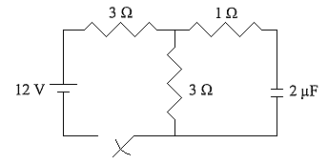

(A) 1 A

(B) 1.5 A

(C) 2 A

(D) 3 A

(E) 4 A

23. Two charges, Q1 = -3.2×l0-10 С and Q2 = +6.4×10-9 C, are separated by a distance of 1 cm. Let F12 be the magnitude of the electrostatic force felt by Q1due to Q2, and let F21 be the magnitude of the electrostatic force felt by Q2 due to Q1. Evaluate the ratio F12/F21.

(A) 0.05

(B) 1

(C) 12.8

(D) 20

(E) 1.6

24. A crane lifts 50 kg 50 m in 10 seconds. It develops a power of

(A) 50 W

(B) 250 W

(C) 750 W

(D) 2500 W

(E) 4500 W

25. If = 200 m/s and *m* = 2 kg, the momentum of the projectile at point *B* is

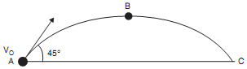

(A) 100–200 kgm/s

(B) 200–300 kgm/s

(C) 300–400 kgm/s

(D) 400–500 kgm/s

(E) 500–600 kgm/s

26. Two capacitors, 0.8 µF and 1.0 µF are connected in parallel and charged to a 120 V potential difference. The capacitors are now discharged and reconnected in series with the same power source. The new total charge acquired is nearest to

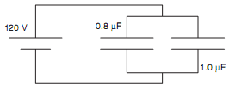

(A) 0.5 µC

(B) 5 µC

(C) 50 µC

(D) 500 µC

(E) 5000 µC

27. A 6 A current through point *A* means that the current through the 3 Ω resistor is

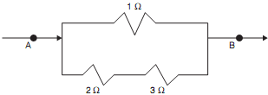

(A) 1 A

(B) 2 A

(C) 3 A

(D) 4 A

(E) 5 A

28. A 1 F capacitor is connected to a 12 V power supply until it is fully charged. The capacitor is then disconnected from the power supply, and used to power a toy car. The average drag force on this car is 2 N. About how far will the car go?

(A) 36 m

(B) 72 m

(C) 144 m

(D) 24 m

(E) 12 m

29. Three resistors are connected to a 10 V battery as shown in the diagram below. What is the current through the 2 Ω resistor?

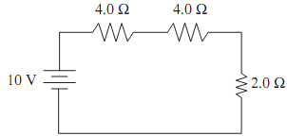

(A) 0.25 A

(B) 0.5 A

(C) 1 A

(D) 2 A

(E) 4 A

30. Three capacitors are connected as shown in the diagram below. *C*1 = 2 µF; *C*2 = 4 µF; *C*3 = 6 µF. If the battery provides a potential of 9 V, how much charge is stored by this system of capacitors?

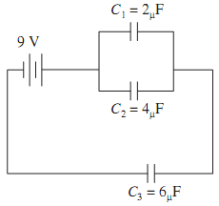

(A) 3 µC

(B) 30 µC

(C) 2.7 µC

(D) 27 µC

(E) 10 µC